The Scott County Fair Needs YOU! (April/May 2018)
Life is full of puzzles, such as, why the best things in life are free and why does winter drag on, while spring and summer fly by? Another mind-bending maxim is why volunteering is often more rewarding than a paid position. Perhaps this is what people mean when they say, “you couldn’t pay me to do this.” Maybe.

To find out you are invited to test that theory at the Scott County Fair, where volunteers are needed before, during and after the Fair. Although there are many opportunities available, let’s highlight four.

People Movers---Drivers of these golf carts get to transport people who excited to see the fair from the parking lot to the fairgrounds; then later taking people tired from spending the day at the fair back to their cars. While volunteering for this job drivers, get to see the fair from a different perspective, while meeting people who have come to see our fabulous fair.

Welcome Booth--If you have the gift of hospitality and like meeting new people, we’ve got the perfect job for you. The Welcome Booth (which is really a tent) is perhaps the most important position at the fair, because it is here where people are greeted with a friendly face, receive valuable information, and have their questions answered.

Grounds Help---We need help getting the grounds ready before the fair, maintaining it during the fair, and putting it back together after the fair. Perhaps you have a green thumb and like working with plants, or maybe you prefer getting both thumbs and eight fingers dirty while working. If not we can get you some gloves while you help us make the grounds presentable for our many guests.

Miracle of Birth---Do you like animals? Help fairgoers experience the birth of farm animals at the fair by volunteering a shift or two in the Miracle of Birth Center.

Please contact us at the Fair office for these and other volunteer opportunities. 952-492-2436 fairofficestaff@scottcountyfair.com We have a place for you at the fair.
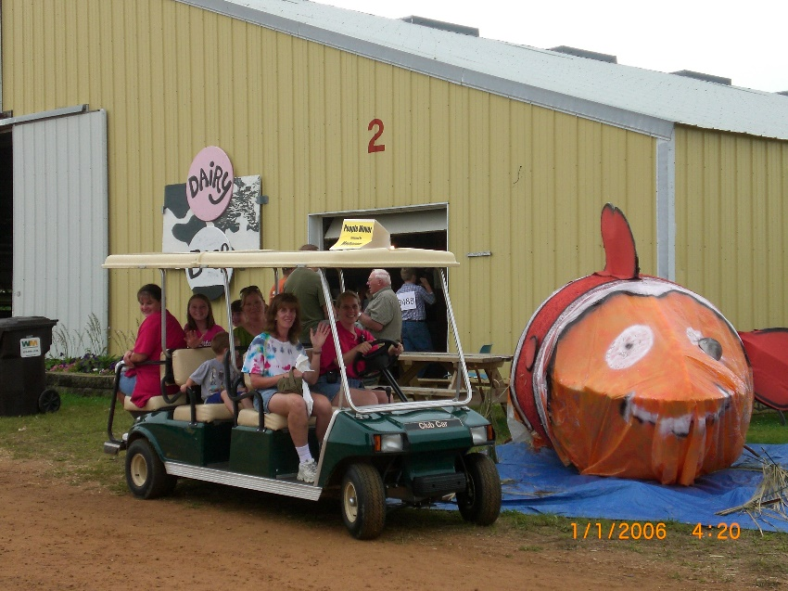
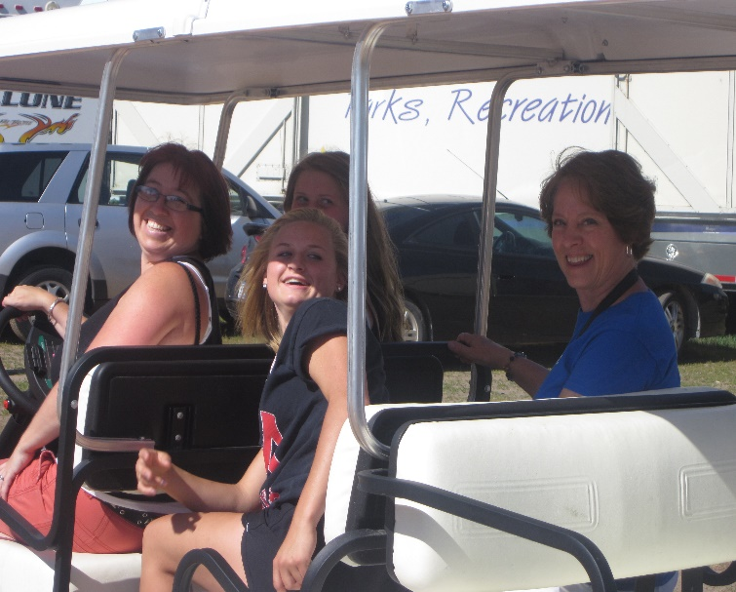

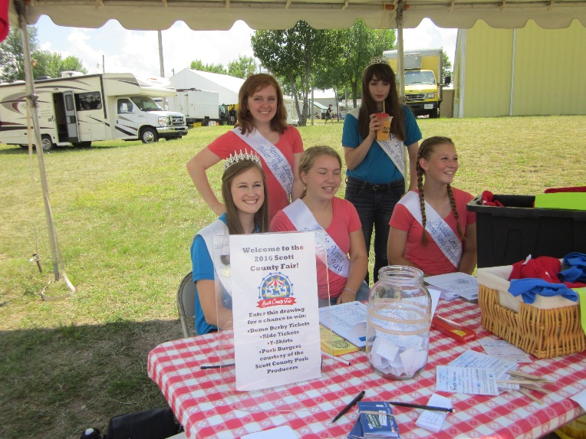
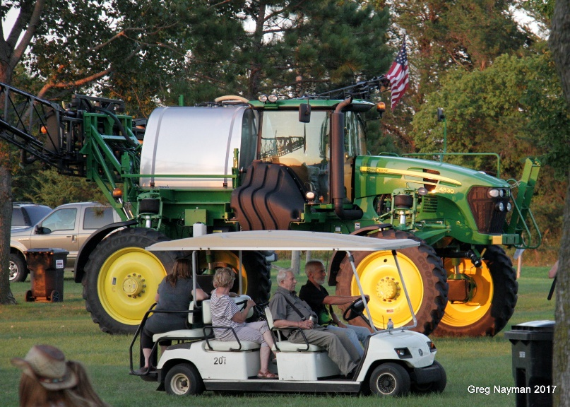
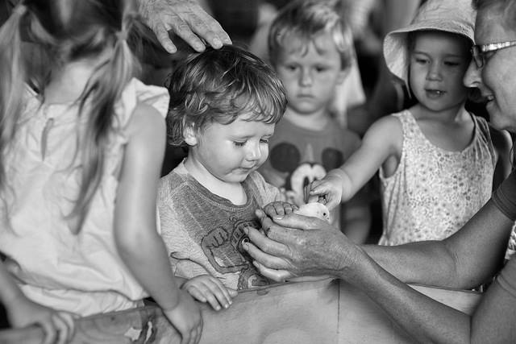
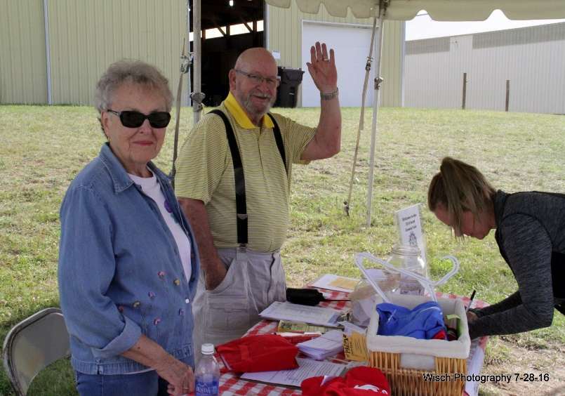

Over 20 years of Draft Horse Shows at the Scott County Fair
The Scott County Fair has one of the largest draft horse shows in the country, with participants from all over the U.S. and Canada. These competitions have grown to include up to 19 six horse hitches, and 17 eight horse hitched. Be sure to mark your calendars and not miss the draft horse shows at the Scott County Fair July 27, 28, and 29.
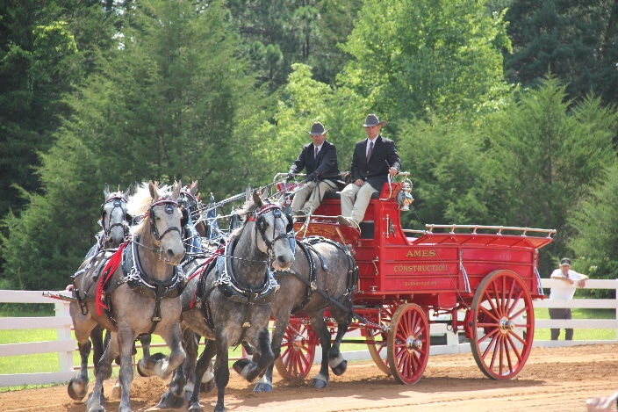
The entire Gentle Giant’s show that aired on RFD TV on Saturday 10/28/17 was about Ames draft horses and the Scott County Fair draft horse shows. In watching this, you realize how fortunate we are to have such awesome draft horse shows at the Scott County Fair with powerful teams of these gentle giants.
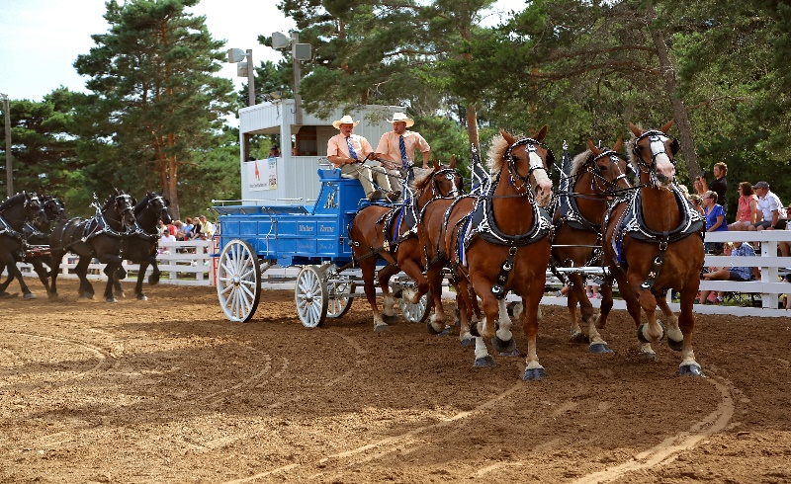
https://www.youtube.com/watch?v=eXQZig_c520&feature=youtu.be

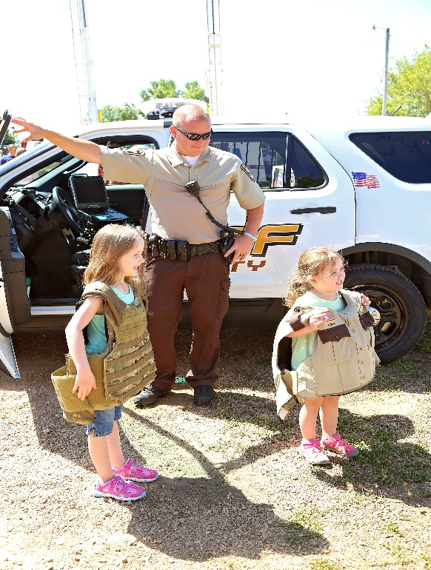
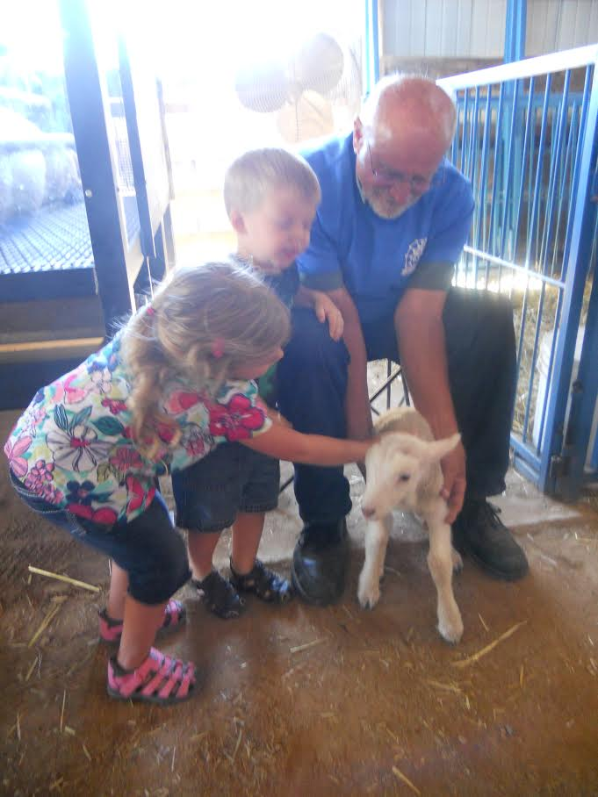

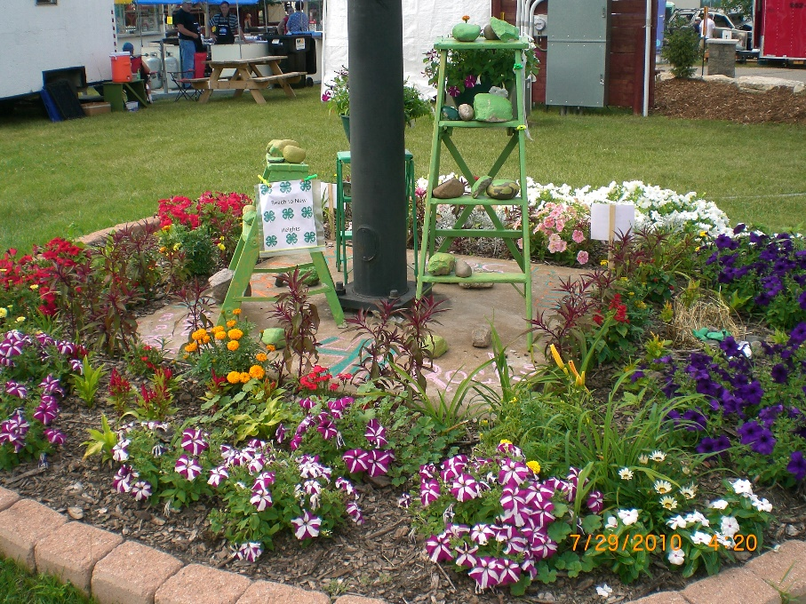

SAVE THE DATE:
July 25-29, 2018
SCOTT COUNTY FAIR

