Scene 5/1/18

Scott County Fair—July 25-29---Five Days You Won’t Forget

Whether it’s five years, five days or five minutes, time seems to fly by. For example, the Scott County Fair is just about here again – and this year’s theme, “Five Days You Won’t Forget,” hints at just how fun the 2018 fair will be.
If you come for the food – we have more food vendors than last year offering unique and delicious treats. If you like the carnival rides, you won’t find a better mix than our fair. We have Amee, our classic carousel, Eli, our vintage Ferris wheel, plus Gold Star, the premiere carnival company, returning this year with even more rides.
Maybe you prefer the grandstand shows. There will be truck and tractor pulls on Wednesday and Thursday, Motokazie moto-cross racing on Sunday, and of course, the demo derby is back on Saturday and promises to pack them again. This year we have added a special showing of Minn-e-rods during Friday night’s monster truck show, which will provide a night of non-stop action. There is a tuff trucks category for individuals to enter their own trucks and compete.
Throughout all five days of the fair there are special free shows and exhibits. The Lumberjack’s are back, The Old West Society will bring you back in time, there is the Mobile Military Museum, a classic car show, magicians, a juggling fire show and more music than you can shake a corn-dog stick at.
Also returning are the very popular Miracle of Birth Center and one of the biggest draft horse shows in the country. Check out the schedule of events: http://www.scottcountyfair.org/ So whatever reason you come to the fair, you will want to invite your family and friends to spend time with you at the Scott County Fair July 25-29. Get there early and often because the time just flies by. You won’t regret it, and you won’t forget it. See you at the fair. . .

Come to the Great County Get Together July 25-29. You’ll be glad you did. It will be
Five Days You Won’t Forget

Kids Day: Thursday July 26--Free Parking Until 1:00 for those with kids in vehicle
- Car Seat Clinic
- Truck Event
- Scott County’s New Read Mobile---Dem Con Recycle Trailer
- Sheltered Realty Student Band
- Metropolitan Dance, River Valley All Stars, Jordan Cheerleaders
- Magic and Fire Shows
- Lumberjack Shows and Kid’s Camp

Senior and Veteran’s Day: Friday July 27 Parking is free until 4 pm for seniors and veterans
- We Three Kings
- One Man Band
- Senior Program
- Free Refreshments for seniors provided by Metropolitan Area Agency on Aging
- 2 Polka Bands
- Bingo

Here 5 Days of the Fair:
- Ag Magic Shows---Norm Barnhart
- All American Lumberjack Shows
- Old West Society Camp
- Military Mobile Museum Camp
- One Man Circus and Fire Shows
- Miracle of Birth
- Gold Star Amusement---first class carnival
- Vintage Ferris Wheel and Carousel

Horse Shows:
Draft Horse Shows: Friday and Saturday 4 pm, Sunday 1 pm
Ranch Rodeo: 6:00 pm Friday
Pleasure: Thursday, Saturday & Sunday starting at 8 am

Grandstand:
Wednesday: NTPA Truck and Tractor Pull
Thursday: Truck and Tractor Pull
Friday: Monster Truck and Minn-e-rod Shows
Saturday: Demo Derby
Sunday: Motokazie (10 am)

Main Stage Bands:
Wed. Dirt Road 7:00-11:00
Thurs. Up South 4:00-8:00
Rhino 8:30-12:30
Fri. Charlie Sticha Band 11:30-3:30
Deep Fried Tweeters 4:00-8:30
32 Below 8:30-12:30
Sat. Band of Brothers 11:30-3:30
Stampede 4:00-8:00
Slama Bama 8:30-12:30
Sun. Triggerfish 11:30-3:00
Everett Smithson 3:30-6:30

Get your exhibits ready for the Fair and register by July 16. http://www.scottcountyfair.org/forms/creative-arts-education-horticulture-registration/

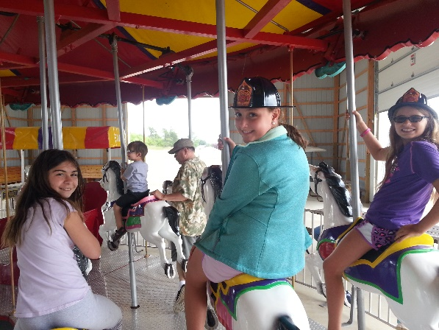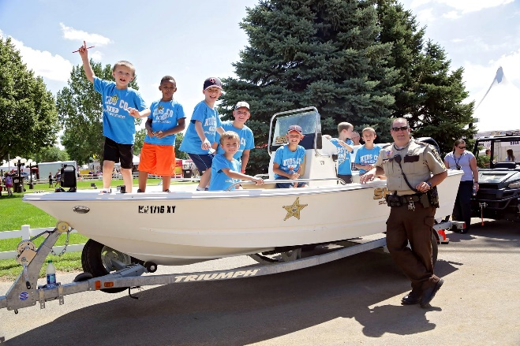
Kid’s Day Thursday July 26--- Free Parking until 1:00 for those with kids in their vehicle.

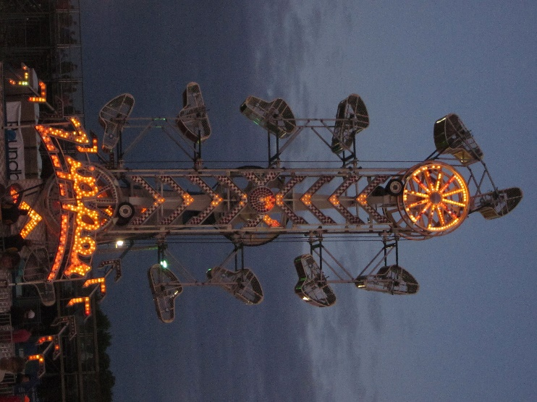
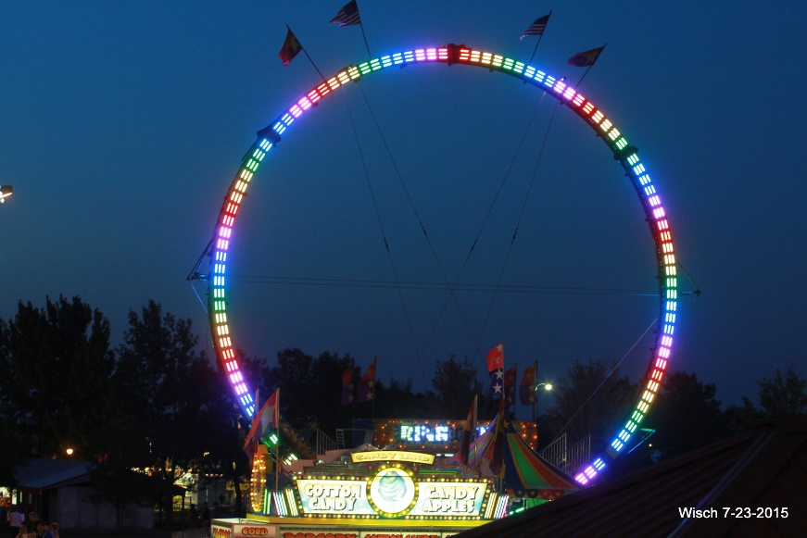
Gold Star Amusements will be bringing the Ring of Fire, the popular Zipper and other rides.

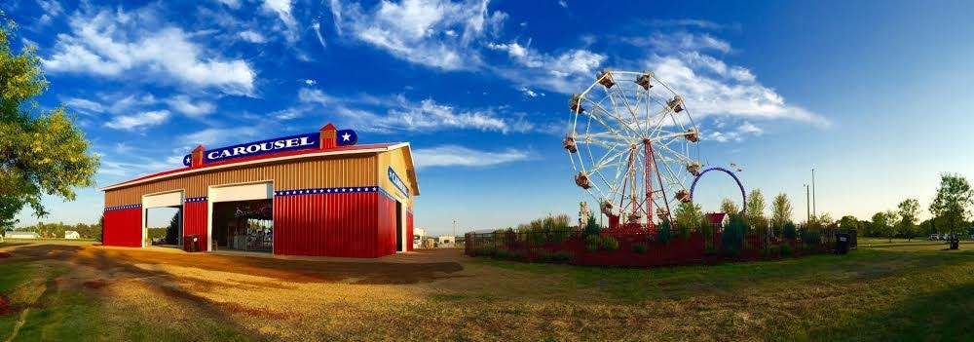
Come ride the vintage carousel and Ferris wheel at the Scott County Fair.
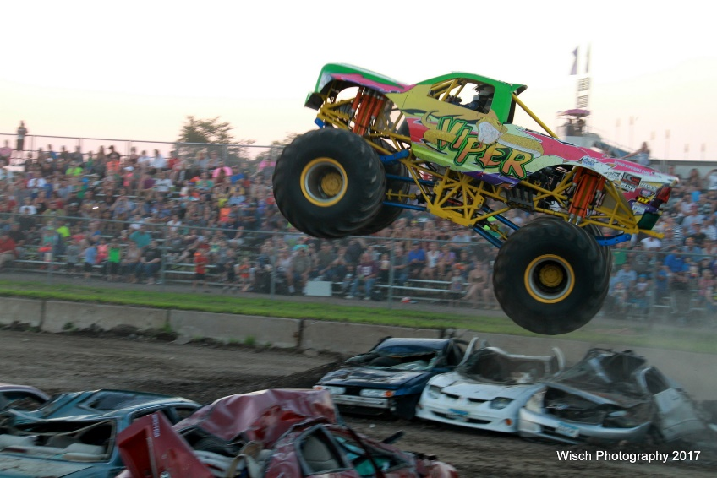

Monster Trucks and Minn-e-rods all at the same
grandstand show Friday July 27
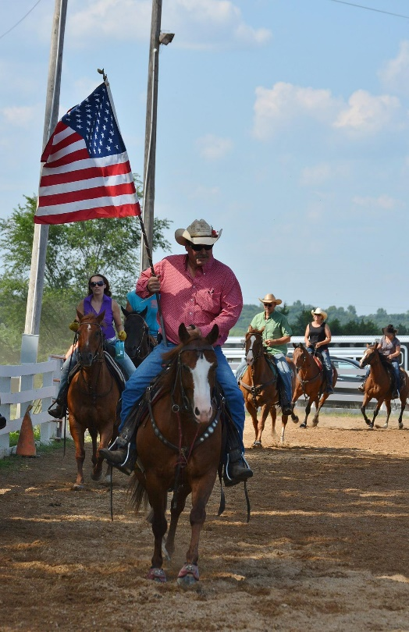
Ranch Rodeo Friday July 27 6:00 pm

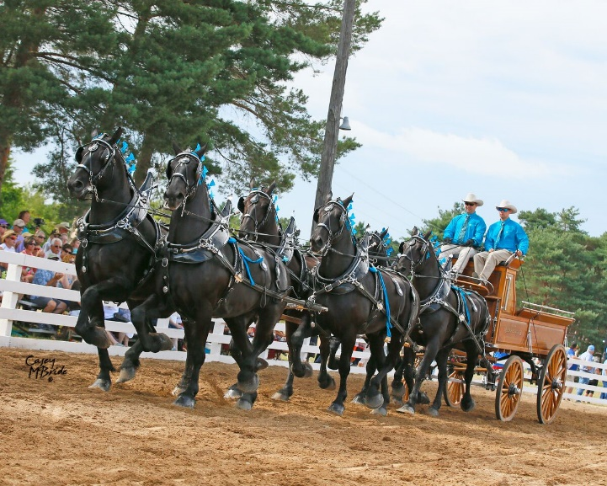
Draft Horse Shows: Fri. & Sat. 4 pm and Sun. 1 pm

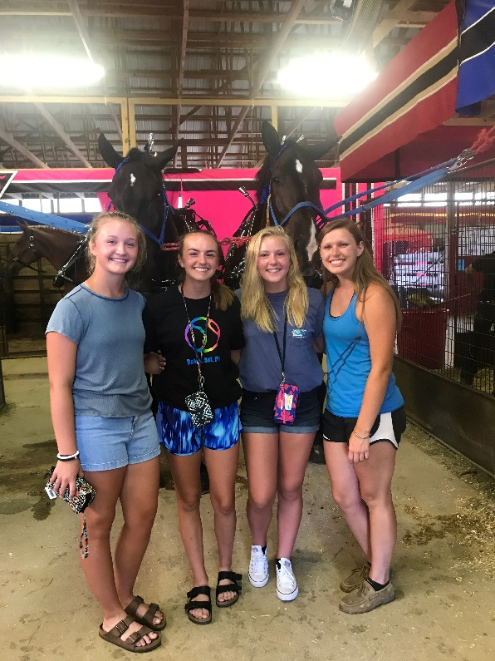
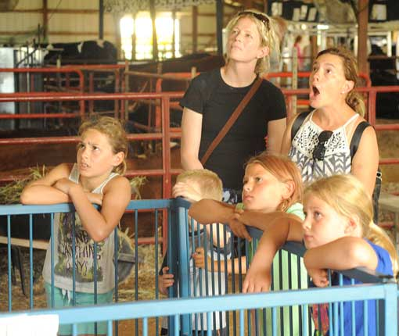
Many are in awe of the live births at the Miracle of
Birth Center at the Scott County Fair.
