What I Did on My Summer Vacation

“What I did on my summer vacation” was once a popular theme when it came time to write a paper for school. That particular essay subject may not have survived the current fade to immediately share everything through social media, but for a moment let us imagine that some teacher somewhere still requires students to report back (on paper) what happened in their summer.

Day At the Scott County Fair
This summer I went to the Scott County Fair with my family and my Grandma. Even though the fair is the last weekend of July, it wasn’t too hot, and everyone found plenty to do.

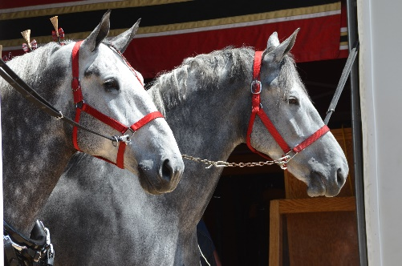
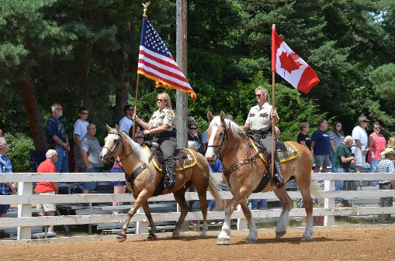
Grandma's favorite was the draft horse show, “One of the biggest shows in North America,” she said. She told us about how her Dad used horses on the farm before tractors were invented. That was hard to imagine, as we saw some old farmer leaning against an old tractor.
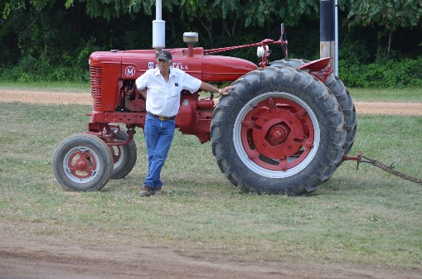

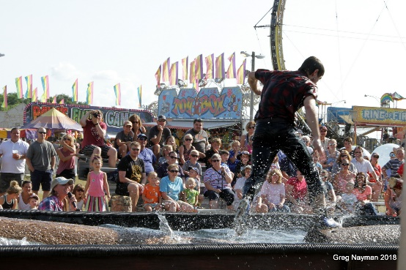
Mom got a kick out of the projects in the Creative Arts and 4-H buildings. She thought it would be a good idea if we joined 4H. It did look like the kids were having fun. Dad enjoyed the Lumberjack Show – especially the log rolling. He told Mom he wanted to try it. She just rolled her eyes. I think she hid his chain saw when we got home.

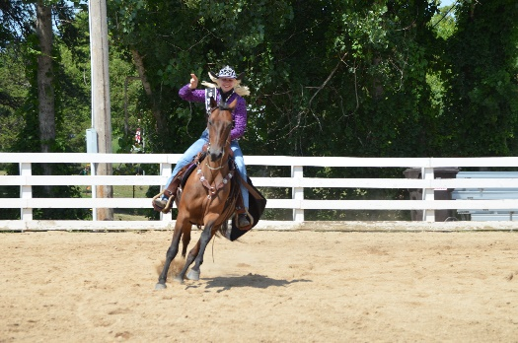
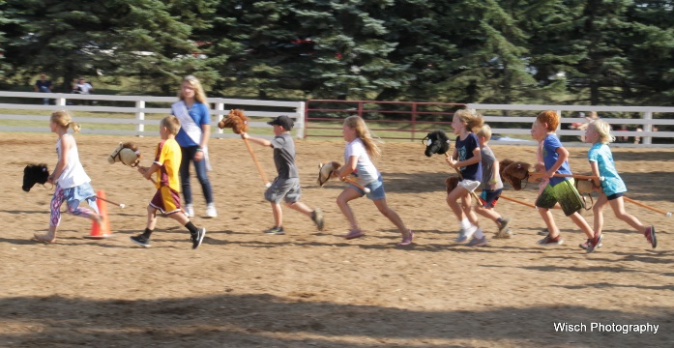
We watched a real rodeo with real cowboys and cowgirls. Then later my sister was in a rodeo with a stick horse. Not the same thing, but she liked it.

I watched a magic show with a real-life magician who made things disappear. When we saw a man juggle stuff that was on fire, Mom said I could not try this at home.
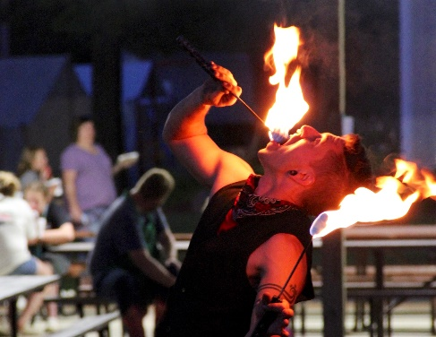
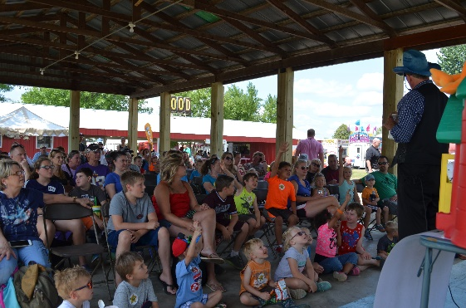

We had lots of stuff to eat; there were so many choices that it was hard to decide. That night we all went to the carnival and rode a bunch of rides.
Our trip to the Scott County Fair was a day I won't forget.
